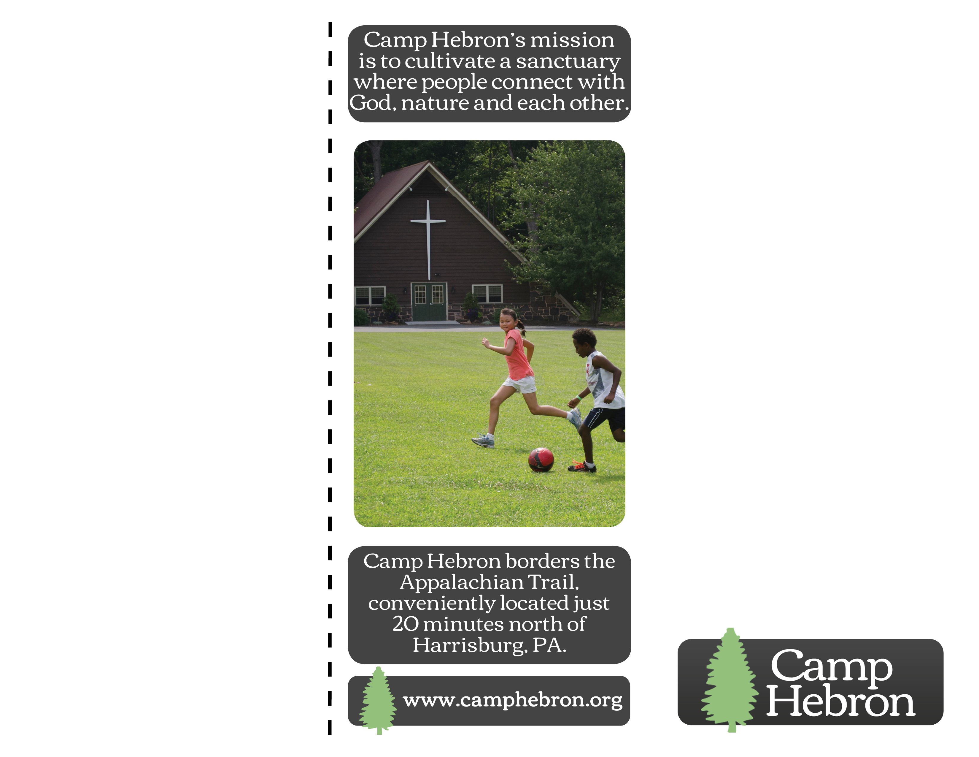

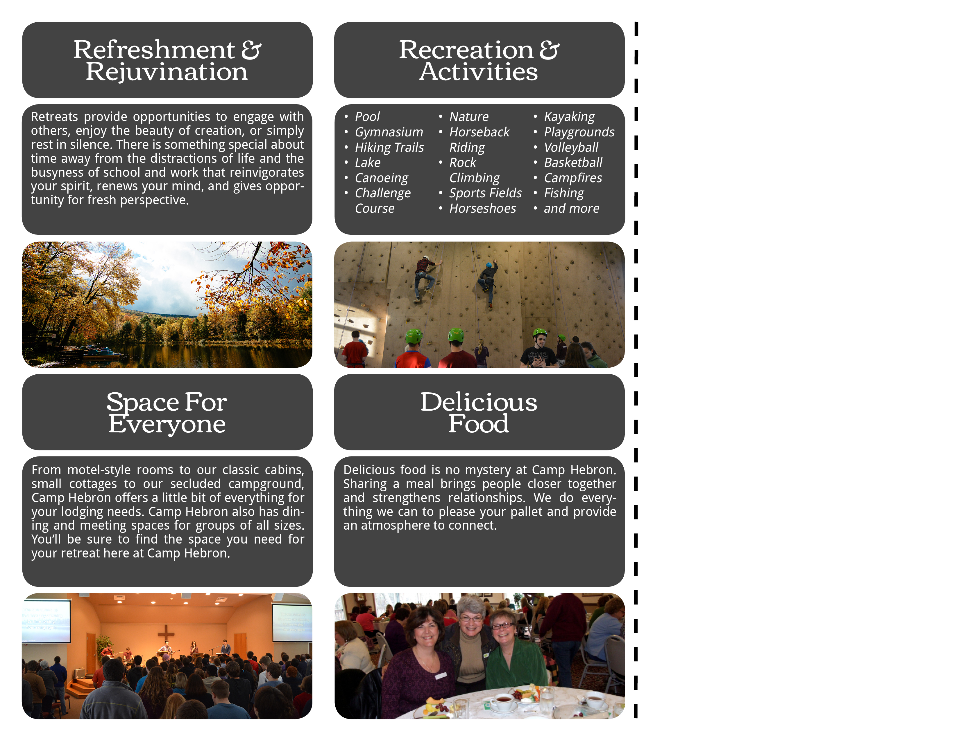

Insert Name of Retreat Here

Insert Church Name and/or Logo Here

Insert Date Range for Retreat Here

Suggested Space for Registration Form or information about your specific programming for your retreat (speaker information, special supplies to bring, departure time, etc.)

Name(s):

Phone:

Address:

Email:

Roommate Request:

Emergency Contact Name:

Emergency Phone:

List Food Allergies:

List Medical Conditions:

Payments are due by:

**Day of the Week, Month Day, Year**

**Submit This Form and Check to:**

Name of Person

Phone Number

Email

Suggested Space for Registration Form or information about your specific programming for your retreat (speaker information, special supplies to bring, departure time, etc.)

Name(s):

Phone:

Address:

Email:

Roommate Request:

Emergency Contact Name:

Emergency Phone:

List Food Allergies:

List Medical Conditions:

Payments are due by:

**Day of the Week, Month Day, Year**

**Submit This Form and Check to:**

Name of Person

Phone Number

Email